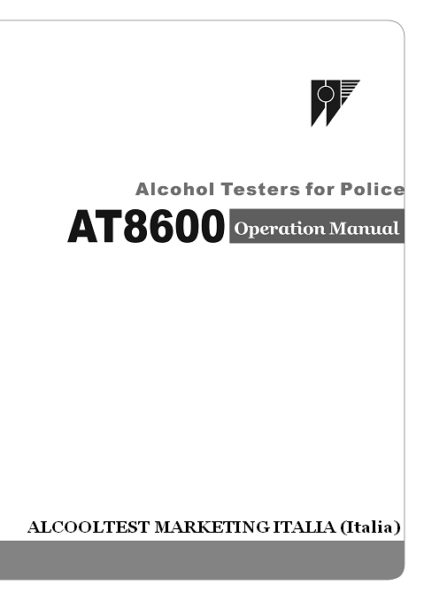
Caratteristiche ed Uso
Contents
Section 1 Description/Descrizione e caratteristiche………...1
Section 2 Configuration& Specification………………………P2
2.1 Out view Layout…….………………………………….….…..P2
2.2 LCD Guide……………………………………………….…....…P2
2.3 Main Functions and Technical Data…………………….....….P2
2.3.1 Main Functions and Features ……………………………..P2
2.3.2 Main Technical Data …………………………………….…....P3
Section 3 Operation Manual ……………………………… ……P3
3.1 Power on and Warm-UP………………………………………..P3
3.1.1 Power On…………………………………………………….....P3
3.1.2 Mouthpiece ………………………………………..…….....P4
3.1.3 Self-Checking………………………………………..…….…...P4
3.1.4 Warm-Up ……………………………………………...….…….P4
3.2 Power Off…………………………………………………….……P5
3.2.1 Off by hand……………………………………………………...P5
3.2.2 Low Voltage ………………………………………………....P5
3.3 Testing Function……………………………………………....…..P5
3.3.1Normal Tester……………………………………………..……..P5
3.3.2 Interruption………………………………………………..…... .P5
3.3.3 Testing Rejection…………………………………………….... P6
3.3.4Passive Testing…………………………………………….....…P6
3.3.5 Low Level…………………………………………………....…..P6
3.3.6 High Level…………………………………………………....….P7
3.3.7 Temperature Overload…………………………………...….….P7
3.3.8 Low Voltage………………………………………………….…. P7
3.4 Specification Setup…………………………………………….…..P7
3.4.1Unit Setup ……………………………………………... ......…..P8
3.4.2Data Upload ……………………………………………..…..P9
3.4.3 Time Setup ………………………………………….…. .P9
3.4.4 Low Level Setup ………………………………………….P10
3.4.5High Level Setup ……………………………………….....P10
3.4.6 Printing Setup……………………………………………….....P11
3.4.7 Calibration …………………………………………………P11
3.4.8 Pressure Sensor Calibration………………………………….P11
3.4.9 Password Management…………………………………….…P11
3.4.10 Exit ………………………………………………….........P12
3.5 Record Checking……………………………………..…….…….P12
Section 4 Battery………………………… ……………... …………P13
4.1Battery Capacity………………………….……….……..………..P13
4.2Battery Charging………………………………………………….P13
4.3Battery Replacement……………………………………………...P14
Section 5 General Problem &Solution……………….................…………P14
Section 6 Accessory ………………………………...……….………P14
Section 7 Notice…………………………………...………… ..……P14

INFORMAZIONI TECNICHE

ATTENZIONE : Il mod. AT8600 è simile ma differisce dal mod. 7410 Plus com , ma ai fini di una trasparente informazione ravvisiamo che il modello AT8600 costa meno ed è più preciso
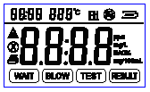
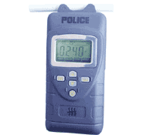

Principio di misurazione : sensore elettrochimico
Memorizzazione dei test: n° 2.000 test circa
Range di rilevazione: da 0,01 a 1.0 mg/L
Display : da 0 a 99.99 mg/L
Tempo del test (misurazione automatica): Tempo per l’espirazione: da 2 a
12 secondi (dipende dalla
intensità dell’espirazione)
Protezione dati : Password Manager personalizzata

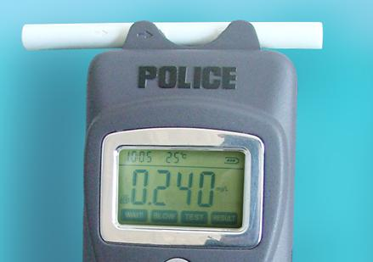
Volume dell’espirato: > 0.3 L
Tolleranza : da 0 a 0.5 mg/L: ± 0.03 mg/L

<0.200 ±0.025

0.200～0.400 ±0.040

0.400～1.000 ±10％
(Prova standard praticata con etanolo) > 0.5 mg/L: ± 5 % sul valore rilevato

Perdita di sensibilità: circa lo 0.6 % sulla somma dei
valori misurato in un mese
Sensibilità trasversale ai gas anestetici. no
Calibratione: ogni 6 mesi
Intervallo di tempo massimo all’inattività: almeno ogni settimana (consigliato)
Dimensioni: (L x H x S) 70 mm x 230 mm x 34 mm
Peso approssimativo: 350 g
Alimentazione: 4 batterie da 1.5 V (type LR 14) o set ricaricabile. 2.1AH，
Autonomia batteria a temperature ambiente: appross. 400 misurazioni or 4-6 h di continua operatività
Interfaccia: RS 232 interface per trasmissione dati al PC
Classificatione Measuring instrument: Class I , con funzione di misurazione

Per la Direttiva 93/42/CEE, Allegato IX Boccaglio in Class I
UMDNS-Code: 17-475

Preface
Reminding Before your testing.
AT8600 Breath tester should be used only to give an indication of the possible presence of alcohol in the breath/blood. You should not rely upon it as the sole basis to determine intoxication or whether it is safe to drive a vehicle, operate equipment, or engage in dangerous activities.
Everyone has different body responds to alcohol consumption and his testing result only as reference, not a subject standard for consequent decision.
The manufacture, importer or distributor takes no responsibility whatsoever for the use of this product for any reason. This product must not be used as a tool for determining whether a person is able to operate a motor vehicle or device legally or safely. The intake of any alcohol will impair reflexes and judgment to operate motor vehicle.
Before your testing, please view the manual carefully and follow the instruction strictly.
Section 1
Description：
AT8600 is kind of portable Breath Alcohol Tester designed for police use, it’s used for checking the breathed alcohol concentration level, can be used in traffic, industrial place, transportation company etc.
This tester adopts big screen with blue backup light, disposable mouthpiece which will keep health, also it can freely reset the alarming level, with audio and visual alarming, accordingly guide information on screen will make operation simple and convenient.
Section2. Configuration & Technical Data
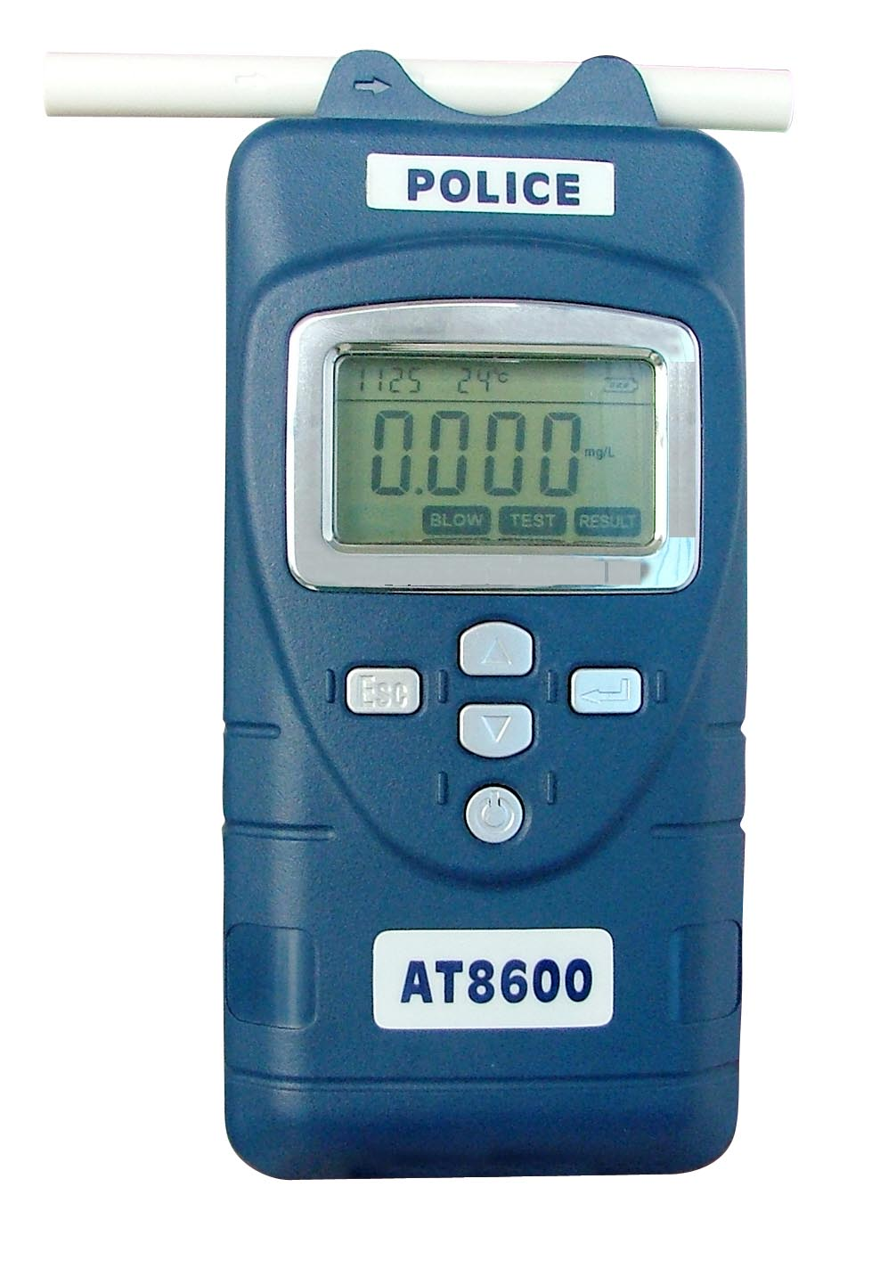
2.1. Outline see pic 1

2.2 LCD indication Guide
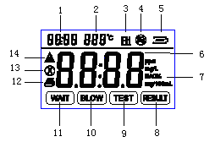
1 | Time Display Zone | 8 | Result I
2 | Temperature Display Zone | 9 | Test I
3 | Low Alarming Level Indication | 10 | Blow I
4 | High Alarming Level Indication | 11 | Wait
5 | Battery Indication | 12 | Printer
6 | Gas concentration Display Zone | 13 | Blow Interruption
7 | Concentration unit Display Zone | 14 | Test Refuse
2.3. Main Features and technical information
2.3.1. Main Features
Adopted 16 bit MCU with low consumption;
LCD Indication; Simple Setup
Real time indication;
Left real battery indication;
Changeable sensor’s module;
Real environment temperature indication;
Low battery reminder;
Temperature exceed alarming
2000 records memory,
Available communication to Computer;
Full Self-check when turns on;
Password management
2.3.2 Main Technical Information:
Sensor Type: Electrochemical Alcohol sensor
Detection Range：0～1.000mg/l
Accuracy： <0.200 ±0.025
0.200～0.400 ±0.040
0.400～1.000 ±10％
Response Time：T＜30s
Working Tem：-10℃～50℃；
Storage Tem：-20℃～60℃；
Working Hum Range：＜95%RH （No Dews）
Shell IP Level：IP55
Power：4×AA NiMH batteries, rating capacity: 2.1AH，
Battery Working Time：Normal testing conditions more than 48h；
Recharging Time：（4～6）h
Section 3. Operation Instruction
3.1. Power on and Warm-up
3.1.1.Power on
Press the “” button, the tester power on.
3.1.2 . Mouthpiece Installation
Take the tester from its package box, turn on it, after its Warm-up finished and “Wait” flashes, then take out the disposable mouthpiece and install it like picture (1).
3.1.3 . Function Self-Check
Turn on the tester, it have Audio and visual self-check first, meantime shown all the information on the screen. Like picture (2)
图2

3.1.4. Warm-Up
Turn on the tester, it will come into counting down Warm-up automatically, during number counting down status, the screen shows Seconds counter, it will show 1 if warm-up finished, shown as picture (2). After this display, the tester enter into normal detecting conditions, the interface of normal detection is as shown in picture (3). Now “Wait” flashes, wait for blowing.
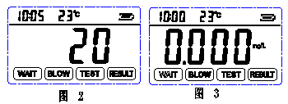
3.2. Turn Off
3.2.1 . Turn off manually
In its detection status, press“”, the tester will cut off its power, there is no information on its screen, at this moment the testers is closed.
3.2.2 .Low Battery Reminder
The tester will give out alarming to remind user for recharging in time if it’s low battery. If the battery is too low, the tester will turn off automatically after power on, enter into low power consumption mode, please take out the batteries for recharging or storage.
3.3. Detection
The tester will enter into normal detection after its Warm-up, the LCD shown as picture (3). On top left side of screen it shows current time, then shows current temperature, current batteries status in turn; and the four readout in middle of screen shows alcohol concentration detected.
In its normal detection conditions, the backup light will open if pressing the Up button for several seconds; and it will be closed if press this button again for another seconds.
3.3.1. Normal detection
- After warm-up, it can be used for normal testing. Install the mouthpiece until “WAIT” flashes in LCD downside, press the enter button, and blow through the mouthpiece at the same time, then “BLOW” will flash. Stop blowing till the tester give out an alarming “di”. Wait for some seconds for the result, the tester will keep the result automatically.
3.3.2. Low level Alarming
If the detecting gas concentration is higher than the low preset level but lower than High level alarming, the tester is in Low Level Alarming status, now its Buzzer will give out intermittent “di – di” sound per second, it will last for 10 – 20S; meantime on the LCD top left side it will show “HI”. And Printer sign flashes, press enter button for printing the result. The screen will keep the result after printing.
If continuous test needed, press”ESC” button after warm-up finished, it will go for next cycle, the tester will warm-up for 10 Seconds then for normal testing. If no need for another test, press the on-off button directly for closing it.
If no printing needed, press “ESC” button, the LCD screen will keep current result until next test begin. Screen shows as picture (4).

3.3.3 .High Level Alarming
If detecting gas concentration is higher than preset high level, the tester is in High Level Alarming status, now its buzzer gives out rapid “ di – di” sound three times per second, it will last 10 – 20S; Meantime on the LCD top right side shows a car sign. And Printer sign flashes, press enter button for printing the result. The screen will keep the result after printing.
If continuous test needed, press ”ESC” button after warm-up finished, it will go for next cycle, the tester will warm-up for 10 Seconds then for normal testing. If no need for another test, press the on-off button directly for closing it.
If no printing needed, press “ESC” button, the LCD screen will keep current result until next test begin. Screen shows as picture (5).
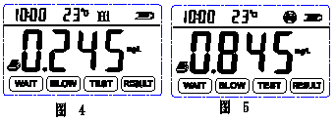
3.3.4. Blow Interrupt conditions
The blowing time must last more than 4S. If the blowing time is too short or intermittent, the tester will remind for blow interrupt conditions. At this time Buzzer give out “di-di” sound for 6 times, get back to testing conditions automatically, shown as picture (6).
3.3.5 . Testing refusing conditions
After 10 Seconds from “BLOW” flashes, if there is still no blow, tester will enter into Refusing test conditions, now Buzzer gives out “di-di” for 6 times, meantime printer flashes, it will print and keep result automatically after press enter button, then return for next test. If no print needed, press “ESC” button, it will not keep the result. Then tester will begin its next test. Shows as picture (7).
After 3 seconds of “BLOW” flashes, “BLOW” and “TEST” will flash at same time, the tester will come into passive detection after pressing the“” button, now the test procedure is same with the normal testing one.
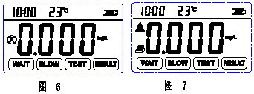
3.4. Parameter setup
When the tester is in Warm-up conditions, shown as picture (2), press “ESC” button, the LCD screen shows as picture (8), remind user to enter the password (password is 1111), it can adjust the Numbers with pressing “” and “”, if first No. setup is finished, press “ESC”, then it will turned on for next No. adjustment, do it in this way in turns, after 4th No. is OK like in picture (9), press enter button, screen shown as in picture (10), it means with correct password, now it’s OK to setup the corresponding parameters. If password is incorrect, then the tester would return to test conditions, now it’s a must to press “ESC” button to enter the new correct password.
Enter into the tester setup status with correct password, user can press the up button “” to choose the parameter setup manual, then confirm it by pressing enter button, at this moment the screen shown as in picture (10). Press up or down button, it will change the corresponding Menu order, user can choose different parameter setup upon the different Number. The default parameter setup is as following:
F－01：Record Data Upload；
F－02：Clock setup；
F－03：Low Alarming Level setup；
F－04：High Alarming Level setup；
F－05：Copies of print setup ；
F－06：Alcohol sensor calibration；
F－07：Pressure sensor calibration；
F－08：Password change；
F－09：Exit setup；
The tester will return back to parameter setup conditions after each parameter setup finished. And it gets back to Warm-Up status if choose exit setup.
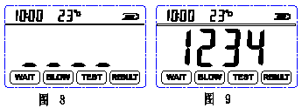
3.4.1. Record Data Upload
The storage data could be transmitted to Computer through RS232 signal. Enter into data setup menu, press up button “”and down button“”, choose F-01(record data transmit), then press button“”to confirm, now begin the transmission. In transmitting process, once one group data is OK, the counter on screen will add one, shown like picture 11.
Press “ESC” button will cancel to stop the transmission.
After the transmission finished, it will return to data setup menu automatically.
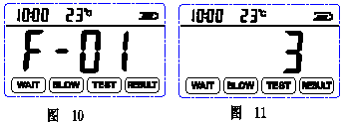

3.4.2. Clock Setup
In data setup menu, press up button “”and down button“”, choose F-02(Clock Setup), press “” button for confirm, it will enter into Clock Setup mode, its setup is in turns of year, month, day, hour, minute. When setup, the clock zone in screen shows in turns, first is year and flash, press up and down button to confirm the No., press confirm button then it will show month and flash, then day, then hour, then minute. After all time setup finished, press confirm button, the screen will show like in picture 12(on top left corner time zone), the detector will show the newest time, and it will return to data setup menu automatically.
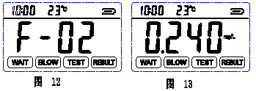

3.4.3. Low Alarming Level Setup
In data setup menu, press up button “”and down button“”, choose F-03(Low Alarming Level Setup), press “” button for confirm, it will enter into Low Alarming Level Setup mode. Press up “” and “”button to adjust the Numbers for setting the alarming point, shown like Picture 13. Press “” to confirm this setting finished, or press “ESC” to cancel setting, then back to setup menu automatically.

3.4.4. High Alarming Point setup
In data setup menu, press up button “”and down button“”, choose F-04(High Alarming Level Setup), press “” button for confirm, it will enter into High Alarming Level Setup mode. Press up “” and “”button to adjust the Numbers for setting the alarming point, shown like Picture 13. Press “” to confirm this setting finished, or press “ESC” to cancel setting, then back to setup menu automatically.

3.4.5. Print Copies Quantity
In data setup menu, press up button “”and down button“”, choose F-05(Printed copies quantity Setup), press “” button for confirm, it will enter into this mode. Press up “” and “”button to adjust the print quantity, shown like Picture 11. Press “” to confirm this setting finished, or press “ESC” to cancel setting, then back to setup menu automatically.
3.4.7.Alcohol Sensor’s Calibration
Menu F-06 is for the inside alcohol sensor’s calibration, we shall provide details when necessary.

3.4.8. Pressure Sensor’s Calibration
Menu F-07 is for the inside pressure sensor’s calibration, we shall provide details when necessary.

3.4.9. Password Amendment
In data setup menu, press up button “”and down button“”, choose F-08(Password Amendment), press “” button for confirm, it will enter into this mode. The tester’s screen will show like picture 8, remind users to reset the password, press “ESC” button, and press “”and“”button to adjust the password Numbers. After one number is setting OK, press “ESC” button, it will turn to next Number automatically, follow this way until the four Numbers are finished, press “” then the tester screen will show “FFFF”, after about 1 second it will remind you to input the new password again, two times input should be same, then press “”, the screen will show like picture 10, shows password setup is successful. Now it has returned back to setup menu.

3.4.10. Exit
In data setup menu, press up button “”and down button“”, choose F-09(Exit), press “” button for confirm, it will return to Warm-Up status.
3.5. Records Check
In Warm-Up status, pressing “” to enter into “History Records query: menu, now the screen will show the saved information in the corresponding zone, this information include temperature, series No. of this group data (at time shown zone) and alarming level, also the alarming time. It’s able to check different Number’s record if press the up “” and down“” button, then press “” button, the details of detecting time (shown like Picture 14,15,16,17), the temporal temperature and testing result. If the records is not reach to 2000pcs, the query will stop till there is no result.
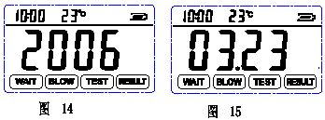
If just enter into query status or checked to the last record, press “” again, you can input the series No. for check, then press the confirm button it will show the time (year, month and day, hour and minute) and concentration. Like shown in Picture 8.
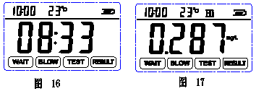

4. Battery Indication and Recharging
4.1. Battery Indication
The tester will have a self-check for its power when turn it on, if the battery is low, it will remind automatically; During its normal working conditions it will check the power at any time also. The battery sign in top right corner of the screen will show the power capacity: Full power, it shows 3 segments indication. Low power, there is not any segment indication inside, at this time, it needs to be recharged. If not, the detector only could work for 15mins continuously. If the power is too low, the tester will turn off automatically, enter into low power consumption mode, now please take out batteries for recharging or storage.
4.2. Battery Recharging
It’s necessary to recharging the batteries if there is low power. There are two methods for recharging, one is use power AC110V-AC220V (Special power adapter); another method is using the car cigarette lighter to recharging. When using AC220V power, plug the adaptor AC terminal to AC220V power, and plug its DC terminal to the charger’s jack, put batteries to the battery slot, (pay attention to battery’s pole correctly), at this time the charger’s indication light is in red, shows recharging begin. Normally this recharging time is 3-4 hours (now the indication light changes from red to green), the batteries can be used normally. However, manufacturer recommends that the recharging time is 4-6 hours, then the batteries would be in better working conditions.

Charge Notice:
Please do not recharge the batteries until it’s exhausted, otherwise it will effect the batteries’ life;
Avoid to use batteries before it’s full recharging;
Please take out batteries when recharged by car cigarette lighter.
4.3. Change Batteries
When batteries can not last for long time working, this may show the batteries exhausted or damaged, please replace with the same type batteries now. Open the battery room, put the batteries according to its positive or cathode pole correctly, then it can be used normally.
If there is no battery, it also can work normally by using Car Cigarette Lighter to get power from the motorcar. If use car power, the batteries must be taken out.
5. General Fault and solution
Fault Description | Possible reason | Solved Measure
Unable to open the tester | Low battery | Recharge in time
Unable to open the tester | Diagram fault | Contact distributors
No response to detection gas | Warm-up not finished | Wait till Warm-up finished
No response to detection gas | Air current fault | Air pressure inadequate
Wrong Display | Over sensor’s lifetime | Contact manufacturer
Wrong Display | Over the specified working conditions | Please used in specified conditions
Wrong Display | Long time no calibration | Calibration in time
Wrong Time Display | Wrong time setup | Reset the time
No use for Zero Calibration | Sensors’ drift much | Calibrate sensors in time or change it
6. Accessories
Tester accessories: 1pc tester, 1pc charger, 1 copy using manual, 5pcs mouthpieces.

7. Notification
- Recommend to calibrate the sensors half a year to keep its accuracy;
- Avoid to use the tester when environment temperature exceed its specified range;
- Any application or fault which not described in this manual, please contact us for more information.

